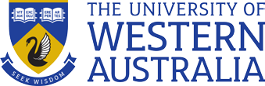

Xiamen University of Technology STUDY TOUR 2018
English & Australian Culture

Study Tour closed class WEEK: 1 DATES: 22.01.18 – 5.02.18
Study Option:
Details:

Group to arrive Saturday 20st January and transferred to UWA CELT for homestay allocation.
Group to depart for home on Sunday 5th Feb.

TIME | MONDAY 22 Jan | TUESDAY 23 Jan | WEDNESDAY 24 Jan | THURSDAY 25 Jan | FRIDAY 26 Jan | SATURDAY 27 Jan
8.45  10.45 | Welcome and campus orientation, computer and WiFi log in, Smartrider information | Introduction/get to know you activities  Cross cultural awareness  Living with an Australian Family | Writing Task  report writing, text model, plan & write  Writing skills  preparation for writing a report vocab, relative clauses | Reading & Listening  Seven Wonders of Australia and New Zealand | National Public Holiday Perth - Australia Day  Enjoy the spectacular fireworks that the families of Perth turn out in their thousands to watch.  An amazing cultural event not to be missed  Bus to pick up from homestay (commencing around 3:00pm) to go to Mr Zhang’s home in South Perth for dinner and fireworks. Return to homestay after fireworks, leaving at around 9:00pm. | Excursion  Moore River and Yanchep national park  8:30 - Bus to pick up students from UWA Claremont campus  Includes picnic lunch  Return by 5pm
Break
11.00  13.00 | Tour of the UWA campus  & Matilda Bay on the famous Swan River | Action Research Project Cross Cultural Awareness  1.write survey questions | Reading & Listening Images of Australia Australia Day celebrations | Writing  Writing a travel advertisement about a place visited in Perth or in China
End of lessons
13.00  15.00 | Free time  Take public transport  to homestay | Field Trip  Visit Perth City  Walking tour of the city center including Elizabeth Quay shopping district, Art Gallery and Museum  Tour finishes at 4.30pm | Free time  Take public transport to homestay | Fremantle City Tour  Walking tour of Fremantle precinct and markets. Pick up from UWA Claremont at 1:00pm outside classes.  Tour finishes at 5:00pm. Public transport to homestay.


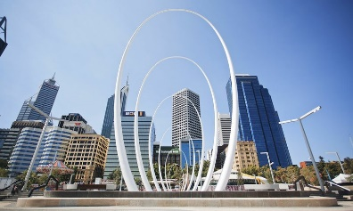

Study Tour closed class WEEK: 2 DATES: 22.01.18 – 4.02.18
Study Option:
Details:

English & Australian Culture

TIME |  | MONDAY 29 Jan | TUESDAY 30 Jan | WEDNESDAY 31 Jan | THURSDAY 1 Feb | FRIDAY 2 Feb | SAT 3 Feb | SUNDAY 4 Feb
8.45  10.45 |  | Reading & Listening  Australia’s  First Inhabitants | Integrated Skills  Famous Australians:  Banjo Paterson  song: Waltzing Matilda | Integrated skills Australian Animals: Dingoes | Reading  Famous Australians: Eddie Mabo | Action Research Project  Cross Cultural Awareness 2.interview Aussie students on campus | Excursion  8.30am – Coach to pick up students from UWA CELT  Caversham Wildlife Park  With  Kangaroos, koalas, wombats, birds, reptiles & farm animals  Bush BBQ  Tasting tour of Swan Valley –  Chocolate, nougat & honey  Free day  With  Homestay family  Practice English in a social setting | Exc Excursion to Caversham  Wildlife Park  From 7:30am – Pick up  from homestay  ursion to Caversham  Wildlife Park  From 7:30am – Pick up  from homestay
Break
11.00  12.00 |  | Speaking  fluency practice: story telling using Aboriginal symbols | Speaking  role play  Looking for a Flat mate | Australian Animals  Fluency practice: celebrity heads with Aussie animals | Vocabulary  Law & Order | Sausage Sizzle
End of lessons
13.00  15.00 | Field Trip to Kings Park. Pick up from UWA Claremont at 1:00pm. Tour finishes at 3:30pm. Public transport to homestay |  | Free time  Public transport home | Sport with local students  Eg: Ultimate Frisbee & Dodgeball | Free time  Public transport home. | Free afternoon or optional UWA CELT student excursions (dates and times permitting).  Excursion details posted Monday of the same week and some fees may apply.


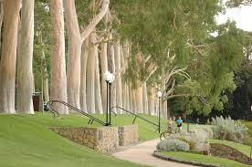
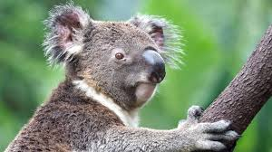

The cost $2,850 per student, not including chaperones. This includes:

1. English for nine half days (Friday 26th January is a public holiday
2. Homestay accommodation including placement fee (Homestay includes weekday breakfast and dinner plus weekend three meals/day)
3. UWA CELT enrolment fee and tuition
4. Traditional Aboriginal Welcome to Country and campus tour
5. Sports with local students
6. Lunches for non-excursion days
7. SmartRider card
8. Graduation lunch
9. Australian day dinner at Simon’s home, 2 days cultural experience tour, airport pick up and drop off.
10. Excluding international air ticket.

