UCC Summer school 2017 |  |  |  |  |   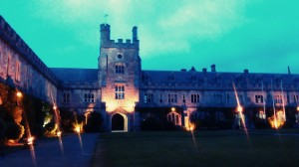  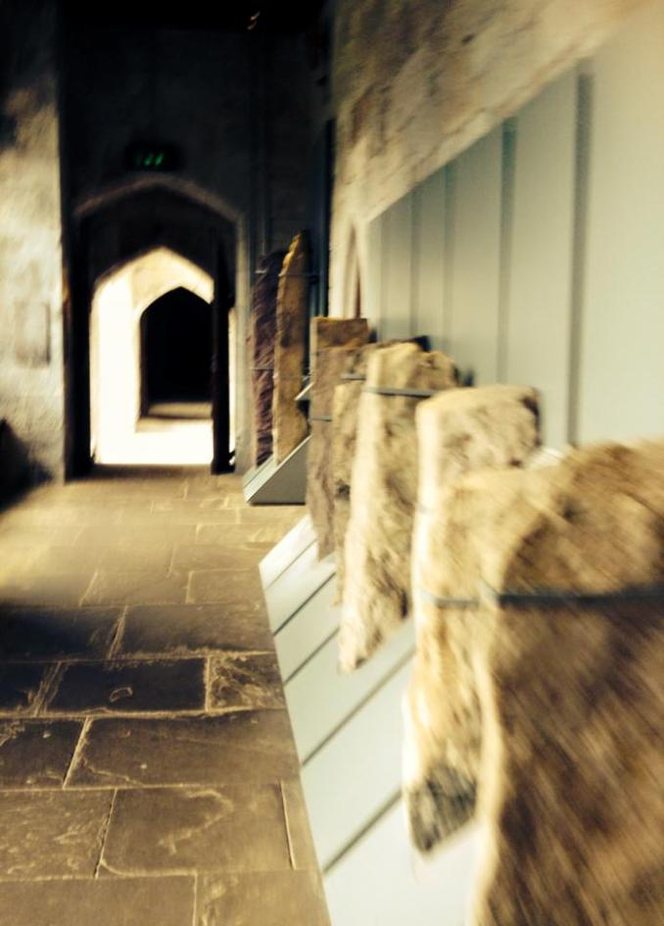  
LENGTH | 3 weeks
dates | 10th July – 31st July 2017
objectives | Language Learning, Multicultural Experience, Study Experience
Price per StudEnT | €2,200

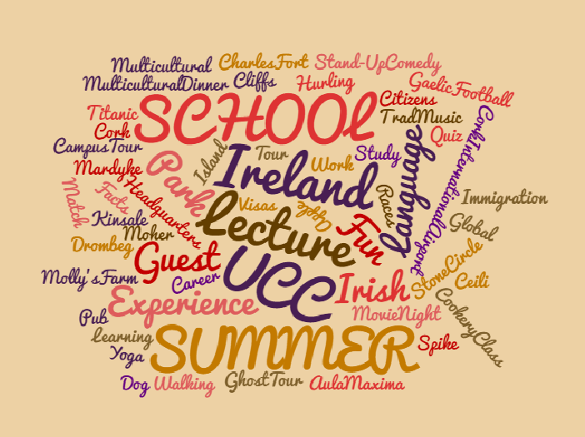
 | Date | morning |  | AFternoon |  |  |  | evening
 | 10th July 2017, Mo | Arrival (pick-up @ Cork Airport) |  | Arrival (pick-up @ Cork Airport) |  |  |  | Arrival (pick-up @ Cork Airport)
 | 11thJuly 2017, Tu | - |  | - |  |  |  | -
 | 12th July 2017, We | English |  | Campus Tour of UCC |  |  |  | Visit to Mardyke Arena
 | 13J^{th}uly 2017, Th | English |  | Apple Site Visit |  |  |  | -
 | 14th July 2017, Fr | English |  | Spike Island |  |  |  | -
 | 15th July 2017, Sa | English |  | Guest Lecture (Government) |  |  |  | Photo Walk & Irish Music Night
 | 16 ^{th}July 2017, Su | English |  | - |  |  |  | Table Quiz
 | 17 ^{th}July 2017, Mo | - |  | - |  |  |  | -
 | 18 ^{th}July 2017, Tu | Bus Tour to Moher Cliffs -> |  |  |  |  |  |  | Arrival to Cork
 | 19 ^{th}July 2017,We | English |  | - |  |  |  | Movie Night @ UCC
 | 20 ^{th}July 2017, Th | English |  | Tyndall Site Visit -
 | 21th July 2017, Fr | English |  | Blackrock Observatory |  |  |  | Ceili, 7 pm @ Lough
 | 22 ^{th}July 2017, Sa | English |  | Irish Food Guest Lecture |  |  |  | Pulses of Tradition at Triskel
 | 23thJuly 2017, Su | English |  | - |  |  |  | Dog Racing
 | 24J^{th}uly 2017, Mo | - | - |  |  |  | -
 | 25thJuly 2017, Tu | Bus Tour to Dublin |  | -> |  |  |  | Arrival to Cork
 | 26thJuly 2017, We | English |  | - |  |  |  | Trad Music Session @ Costigans
 | 27 ^{th}July 2017, Th | English |  | Blizzard Site Visit |  |  |  | -
 | 28th July 2017, Fr | English |  | Blarney Castle & Gardens |  | -
 | 29thJuly 2017, Sa | English |  | Guest Lecture |  |  |  | Ghost Tour
 | 30 ^{th}July 2017, Su | English |  | - |  |  |  | Farewell Ceremony
 | 31th July 2017, Mo | Departure (drop-off @ Cork Airport) |  | - |  |  |  | -

NB: Price excludes flight ticket and visa processing. Social activities and industrial visits are subject to weather condition and availability.

